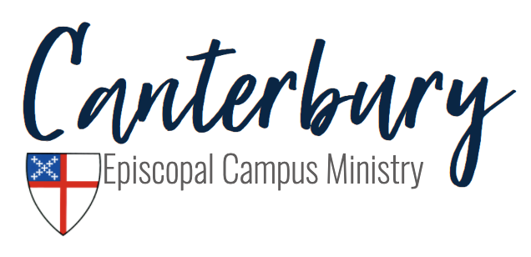
Fall 2021 Covid-19 Guidelines

Hi everyone! We are so excited to begin another semester with returning members and new members! With the rise of the delta variant of covid-19 and the uncertainty around what will happen when students return to campus from different locations, we have decided to err on the side of caution with our guidelines. If you have any questions, comments, or concerns about the following guidelines, please feel free to reach out to anyone on Vestry.

- Whenever we are inside the building, we will wear masks and social distance when possible.
- When we are outside, masks are not required, but socially distancing is. If we cannot social distance, masks will be worn.
- If you are not vaccinated, we ask you to please wear a mask both inside and outside, regardless of social distancing.
- During Holy Eucharist, the bread is served but not the wine.
- We are allowed to sing during worship while wearing masks
- Rides will be provided. Masks will be worn inside the cars with the windows down for air circulation!
- Services will continue to be streamed on Facebook Live for those who are uncomfortable or unable to join us in person!

We are so excited for this first semester in our new building! As always, please be flexible as we might need to change these guidelines as JMU and the Episcopal Diocese of Virginia provide guidance. Check out our social media for upcoming event reminders! If you have any questions, please feel free to reach out to Rev. Laura Lockey (minniclk@gmail.com) or anyone on Vestry. Stay safe!
